**AI-Enhanced Book Club.**

Course-end Project 1

Description

**Problem Scenario:**

The aim of this project is to harness ChatGPT's capabilities to enhance your creativity and writing skills. You will utilize ChatGPT as a tool to generate unique and captivating written content. The focus will be on creative writing, and no external data gathering will be required.

**Problem Objective:**

The objective of this project is to explore the potential of ChatGPT in supporting your creative writing journey. Through prompt-based writing sessions, you will be encouraged to unleash your imagination and express yourself freely.

**Solution**

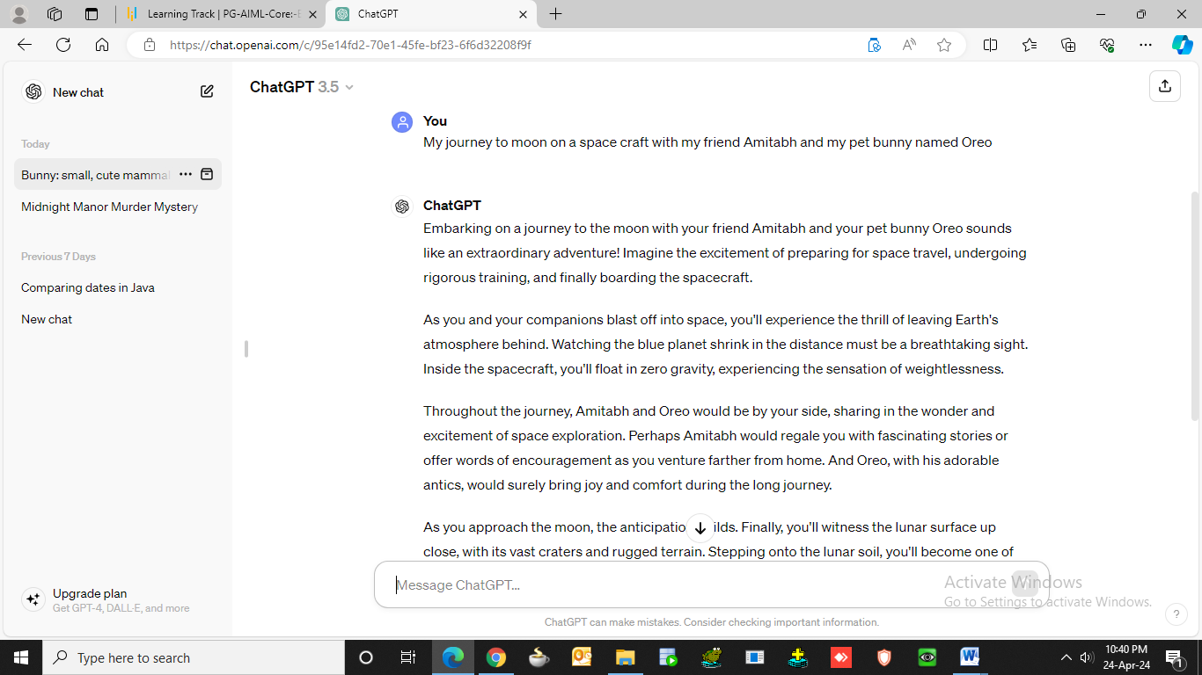

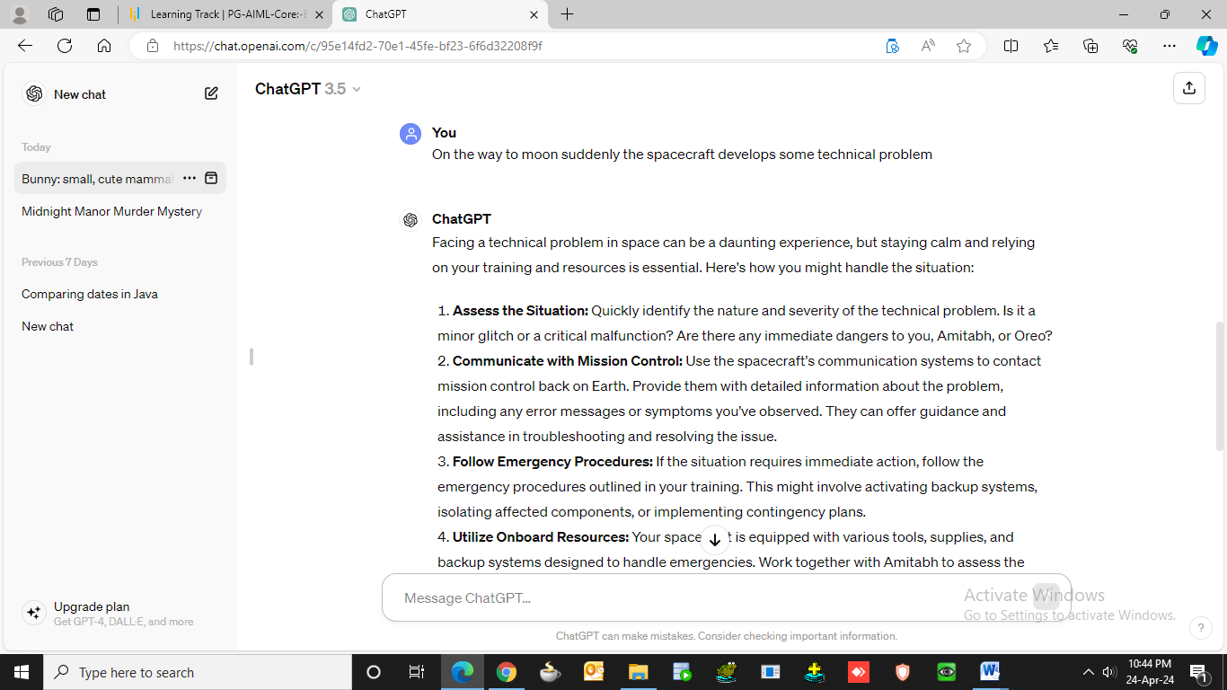

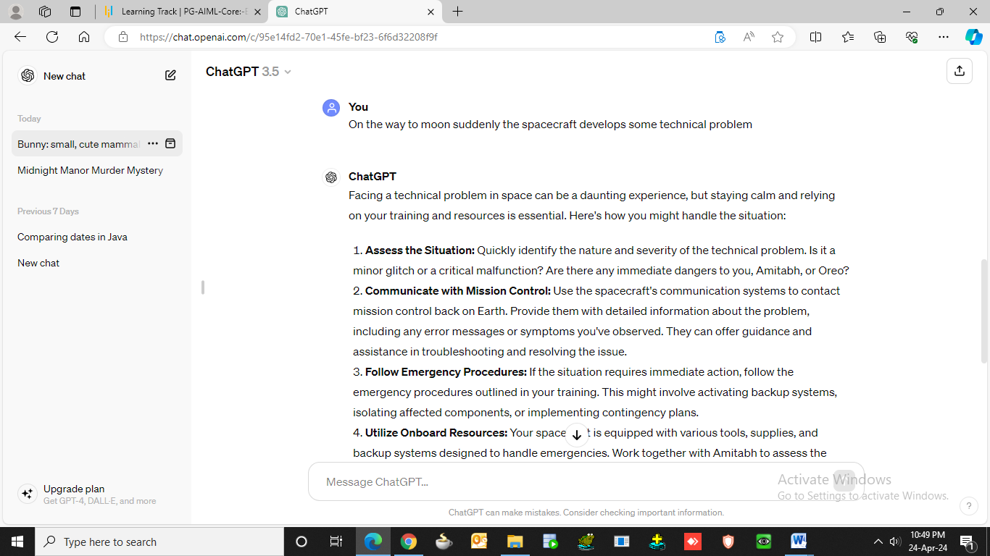

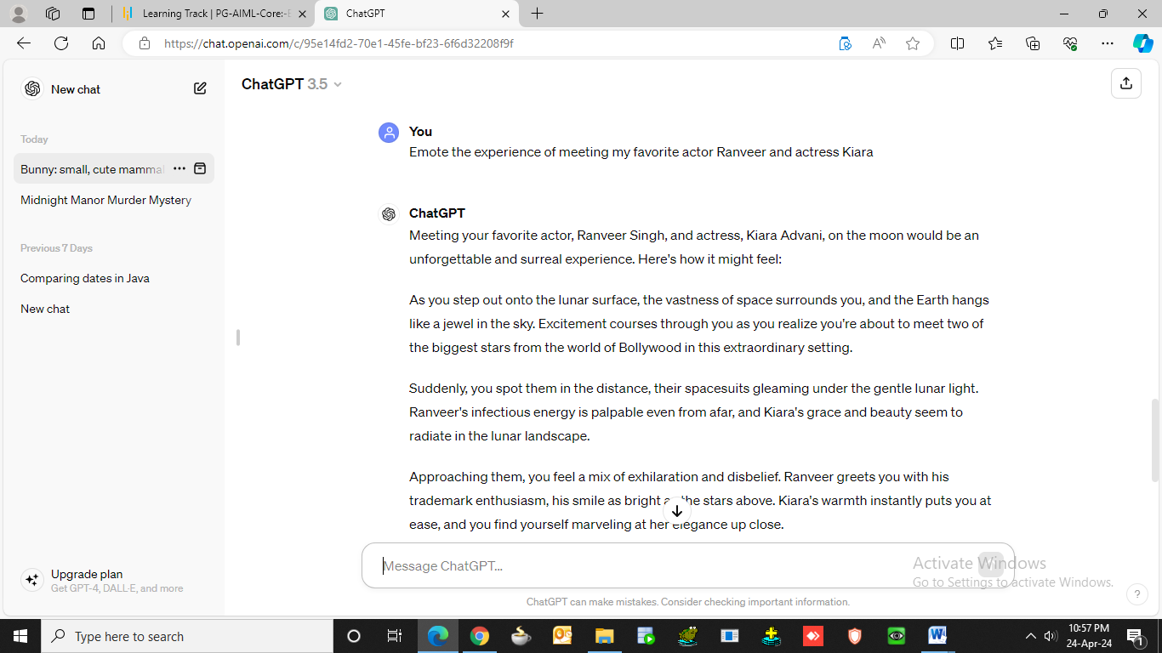

**Moon Walk**

Embarking on a journey to the moon with your friend Amitabh and your pet bunny Oreo sounds like an extraordinary adventure! Imagine the excitement of preparing for space travel, undergoing rigorous training, and finally boarding the spacecraft.

As you and your companions blast off into space, you'll experience the thrill of leaving Earth's atmosphere behind. Watching the blue planet shrink in the distance must be a breathtaking sight. Inside the spacecraft, you'll float in zero gravity, experiencing the sensation of weightlessness.

Throughout the journey, Amitabh and Oreo would be by your side, sharing in the wonder and excitement of space exploration. Perhaps Amitabh would regale you with fascinating stories or offer words of encouragement as you venture farther from home. And Oreo, with his adorable antics, would surely bring joy and comfort during the long journey.

As you approach the moon, the anticipation builds. Finally, you'll witness the lunar surface up close, with its vast craters and rugged terrain. Stepping onto the lunar soil, you'll become one of the few humans to set foot on another celestial body, a momentous achievement in the history of space exploration.

Exploring the lunar landscape with Amitabh and Oreo would be an unforgettable experience, filled with wonder and awe. Together, you'd capture memories, conduct experiments, and marvel at the beauty of the cosmos.

Facing a technical problem in space can be a daunting experience, but staying calm and relying on your training and resources is essential. Here's how you might handle the situation:

1. **Assess the Situation**: Quickly identify the nature and severity of the technical problem. Is it a minor glitch or a critical malfunction? Are there any immediate dangers to you, Amitabh, or Oreo?

2. **Communicate with Mission Control**: Use the spacecraft's communication systems to contact mission control back on Earth. Provide them with detailed information about the problem, including any error messages or symptoms you've observed. They can offer guidance and assistance in troubleshooting and resolving the issue.

3. **Follow Emergency Procedures**: If the situation requires immediate action, follow the emergency procedures outlined in your training. This might involve activating backup systems, isolating affected components, or implementing contingency plans.

4. **Utilize Onboard Resources**: Your spacecraft is equipped with various tools, supplies, and backup systems designed to handle emergencies. Work together with Amitabh to assess the available resources and devise a plan to address the technical problem.

5. **Stay Calm and Focused**: It's natural to feel anxious or stressed in such a situation, but maintaining a calm and focused demeanor is crucial. Keep communication channels open with Amitabh and mission control, and work together methodically to troubleshoot and resolve the issue.

6. **Consider Safety Measures**: Depending on the severity of the problem, you may need to take precautions to ensure the safety of everyone aboard. This might involve donning protective gear, securing loose objects, or preparing for emergency procedures such as a controlled re-entry or evacuation.

7. **Maintain Hope and Optimism**: Remember that you're part of a highly trained and capable team, both onboard the spacecraft and back on Earth. By working together and remaining determined, you can overcome challenges and continue your journey to the moon.

Facing adversity in space is a testament to human resilience and ingenuity. With careful planning, teamwork, and perseverance, you can navigate through technical difficulties and continue your extraordinary journey to the moon.

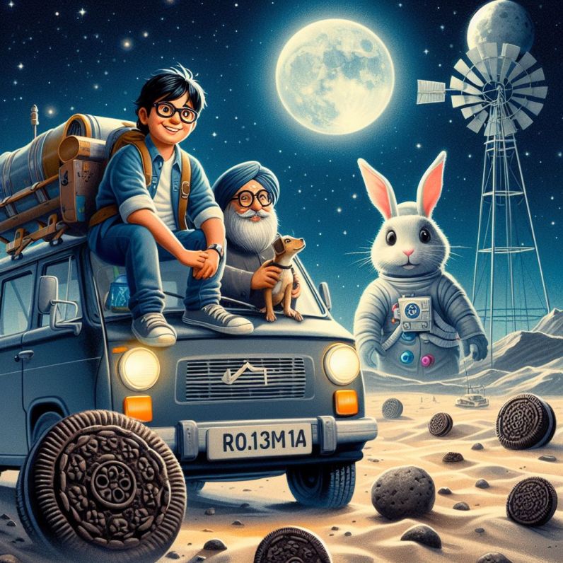**An Encounter with Ranveer and Kiara on Moon**

Meeting your favorite actor, Ranveer Singh, and actress, Kiara Advani, on the moon would be an unforgettable and surreal experience. Here's how it might feel:

As you step out onto the lunar surface, the vastness of space surrounds you, and the Earth hangs like a jewel in the sky. Excitement courses through you as you realize you're about to meet two of the biggest stars from the world of Bollywood in this extraordinary setting.

Suddenly, you spot them in the distance, their spacesuits gleaming under the gentle lunar light. Ranveer's infectious energy is palpable even from afar, and Kiara's grace and beauty seem to radiate in the lunar landscape.

Approaching them, you feel a mix of exhilaration and disbelief. Ranveer greets you with his trademark enthusiasm, his smile as bright as the stars above. Kiara's warmth instantly puts you at ease, and you find yourself marveling at her elegance up close.

In this otherworldly setting, conversation flows effortlessly as you share stories and laughter with your favorite stars. Ranveer regales you with tales of his adventures, while Kiara captivates you with her charm and wit.

Together, you take in the breathtaking lunar scenery, posing for photos against the backdrop of cratered landscapes and distant stars. It's a moment frozen in time, etched forever in your memory as one of the most surreal and magical experiences of your life.

As you bid farewell to Ranveer and Kiara, the realization sinks in that you've just shared a moment of connection with two of your idols in the most extraordinary of settings. Walking back to your spacecraft, you're filled with gratitude for this once-in-a-lifetime encounter, knowing that the memories of this day will stay with you forever.

After your adventure on the moon, it would be time to return home, carrying with you memories that would last a lifetime. And as you re-enter Earth's atmosphere and touch down safely, you'll cherish **the** bonds forged during your incredible journey to the moon.